

**COMPUTER ENGINEERING**

**DS ODD SEM 2021-22/EXPERIMENT 6 NAME:- GAURAV AMARNANI (D7A, 67)**

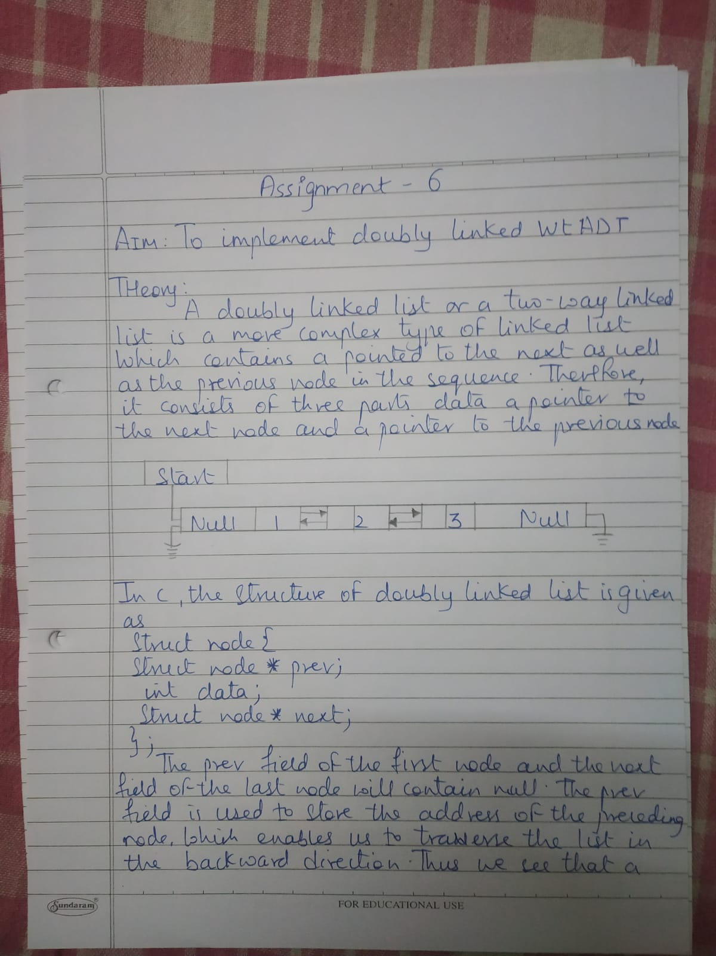

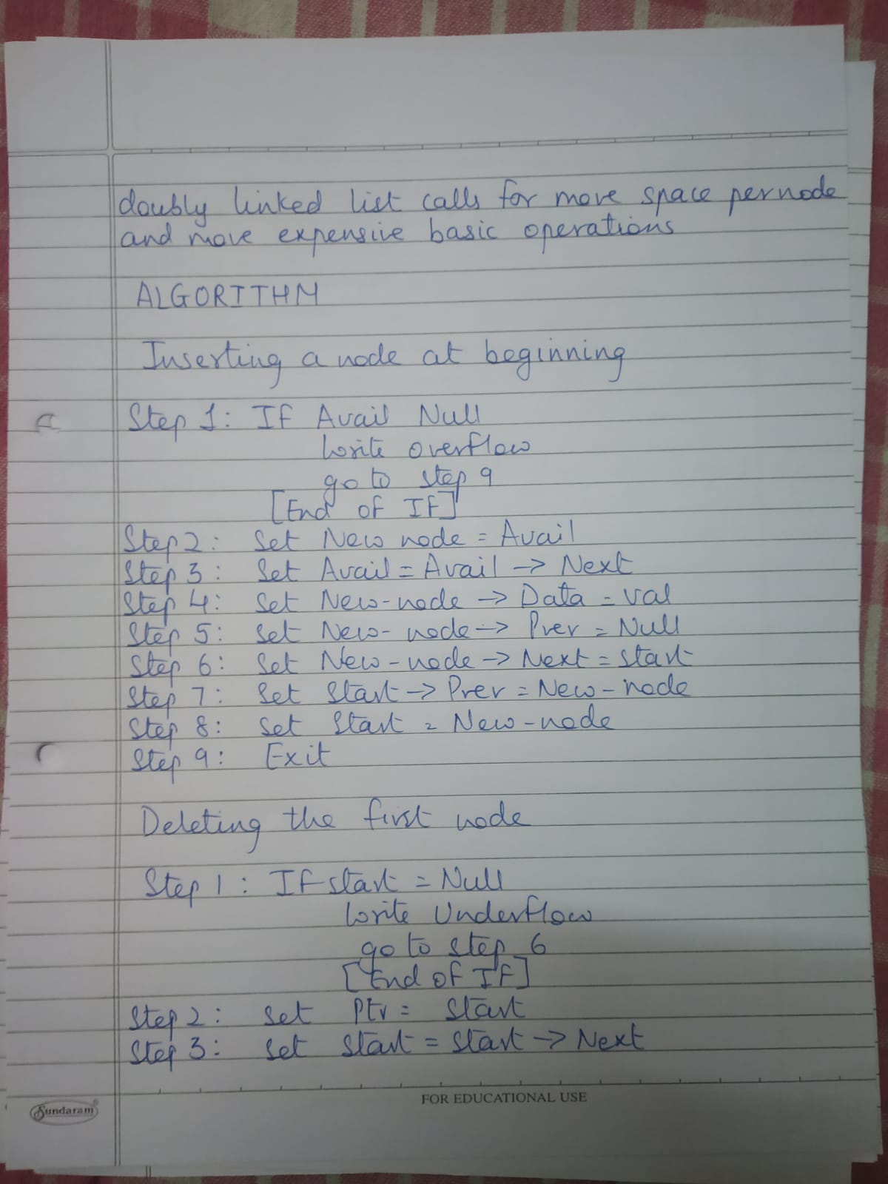

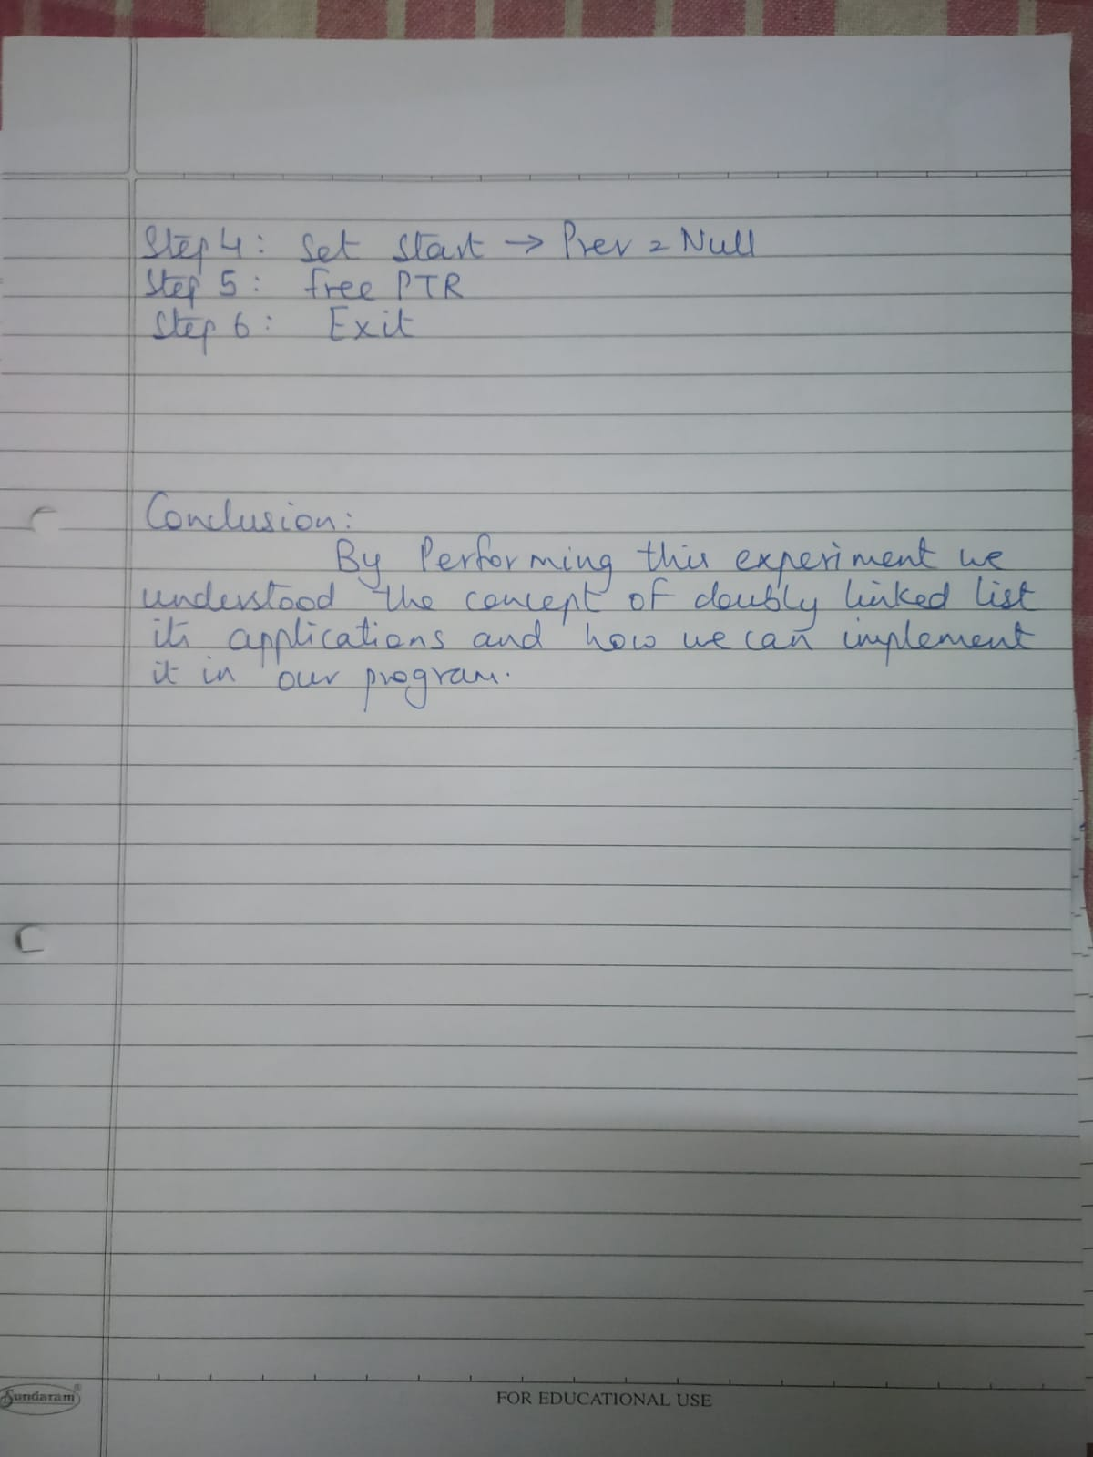

**PROGRAM:**

#include<stdio.h>

#include<stdlib.h>

struct node {

struct node *prev;

struct node *next;

int data;

};

struct node *head;

void insertion_beginning();

void insertion_last();

void insertion_specified();

void deletion_beginning();

void deletion_last();

void deletion_specified();

void display();

void search();

void main () {

int choice =0;

while(choice != 9) {

printf("\nChoose one option from the following list ...\n");

printf("\n1.Insert in begining\n2.Insert at last\n3.Insert at any random location\n4.Delete from Beginning 5.Delete from last\n 6.Exit\n");

printf("\nEnter your choice?\n");

scanf("\n%d",&choice);

switch(choice) {

case 1:

insertion_beginning();

break;

case 2:

insertion_last();

break;

case 3:

insertion_specified();

break;

case 4:

deletion_beginning();

break;

case 5:

deletion_last();

break;

case 6:

exit(0);

default:

printf("Please enter valid choice..");

}

}

}

void insertion_beginning() {

struct node *ptr;

int item;

ptr = (struct node *)malloc(sizeof(struct node));

if(ptr == NULL) {

printf("\nOVERFLOW");

}

else {

printf("\nEnter Item value");

scanf("%d",&item);

if(head==NULL) {

ptr->next = NULL;

ptr->prev=NULL;

ptr->data=item;

head=ptr;

}

else {

ptr->data=item;

ptr->prev=NULL;

ptr->next = head;

head->prev=ptr;

head=ptr;

}

printf("\nNode inserted\n");

}

}

void insertion_last() {

struct node *ptr,*temp;

int item;

ptr = (struct node *) malloc(sizeof(struct node));

if(ptr == NULL) {

printf("\nOVERFLOW");

}

else {

printf("\nEnter value");

scanf("%d",&item);

ptr->data=item;

if(head == NULL) {

ptr->next = NULL;

ptr->prev = NULL;

head = ptr;

}

else {

temp = head;

while(temp->next!=NULL) {

temp = temp->next;

}

temp->next = ptr;

ptr ->prev=temp;

ptr->next = NULL;

}

}

printf("\nnode inserted\n");

}

void insertion_specified() {

struct node *ptr,*temp;

int item,loc,i;

ptr = (struct node *)malloc(sizeof(struct node));

if(ptr == NULL) {

printf("\n OVERFLOW");

}

else {

temp=head;

printf("Enter the location");

scanf("%d",&loc);

for(i=0;i<loc;i++) {

temp = temp->next;

if(temp == NULL) {

printf("\n There are less than %d elements", loc);

return;

}

}

printf("Enter value");

scanf("%d",&item);

ptr->data = item;

ptr->next = temp->next;

ptr -> prev = temp;

temp->next = ptr;

temp->next->prev=ptr;

printf("\nnode inserted\n");

}

}

void deletion_beginning() {

struct node *ptr;

if(head == NULL) {

printf("\n UNDERFLOW");

}

else if(head->next == NULL) {

head = NULL;

free(head);

printf("\nnode deleted\n");

}

else {

ptr = head;

head = head -> next;

head -> prev = NULL;

free(ptr);

printf("\nnode deleted\n");

}

}

void deletion_last() {

struct node *ptr;

if(head == NULL) {

printf("\n UNDERFLOW");

}

else if(head->next == NULL) {

head = NULL;

free(head);

printf("\nnode deleted\n");

}

else {

ptr = head;

if(ptr->next != NULL) {

ptr = ptr -> next;

}

ptr -> prev -> next = NULL;

free(ptr);

printf("\nnode deleted\n");

}

}

void deletion_specified() {

struct node *ptr, *temp;

int val;

printf("\n Enter the data after which the node is to be deleted : ");

scanf("%d", &val);

ptr = head;

while(ptr -> data != val) ptr = ptr -> next;

if(ptr -> next == NULL) {

printf("\nCan't delete\n");

}

else if(ptr -> next -> next == NULL) {

ptr ->next = NULL;

}

else {

temp = ptr -> next;

ptr -> next = temp -> next;

temp -> next -> prev = ptr;

free(temp);

printf("\nnode deleted\n");

}

}

void display() {

struct node *ptr;

printf("\n printing values...\n");

ptr = head;

while(ptr != NULL) {

printf("%d\n",ptr->data);

ptr=ptr->next;

}

}

void search() {

struct node *ptr;

int item,i=0,flag;

ptr = head;

if(ptr == NULL) {

printf("\nEmpty List\n");

}

else {

printf("\nEnter item which you want to search?\n");

scanf("%d",&item);

while (ptr!=NULL) {

if(ptr->data == item) {

printf("\nitem found at location %d ",i+1);

flag=0;

break;

}

else {

flag=1;

}

i++;

ptr = ptr -> next;

}

if(flag==1) {

printf("\nItem not found\n");

}

}

}

OUTPUT:-

